**Ideation Phase**

**Brainstorm & Idea Prioritization Template**

| Date | 2025-03-03 |
| --- | --- |
| Team ID | Team-145269 |
| Project Name | Flight Finder |
| Maximum Marks | 4 Marks |

**Brainstorm & Idea Prioritization Template:**

In today’s increasingly connected world, the ability to efficiently manage travel has become more of a necessity than a luxury. Whether for business trips, vacations, or visiting loved ones, travellers and travel providers alike rely heavily on digital platforms to streamline the booking process. However, many existing flight booking solutions fall short when it comes to offering a user-centric, secure, and fully integrated travel management ecosystem.

For airlines and travel agencies, creating and managing flight schedules and bookings often becomes a tedious and fragmented process. Many platforms limit customization, lack intuitive booking management tools, or require a steep technical learning curve — which

discourages travel professionals from fully embracing digital solutions. Additionally, the absence of automated systems for managing passenger information, handling booking modifications, and generating reports makes it difficult for them to scale their operations and maintain service quality.

For customers, the booking experience is often disrupted by complex interfaces, lack of real-time updates, and disconnected information. In the absence of clear flight options, secure payment gateways, and efficient communication channels, travellers tend to experience frustration, resulting in lost bookings and decreased satisfaction.

Administrators, too, face unique hurdles. Managing user accounts, moderating bookings, handling secure payments, and monitoring system performance across a growing user base are essential but complex tasks. Most platforms require separate plugins, manual interventions, or even third-party services to accomplish what should ideally be part of a unified system.

Security is another major concern for both travel providers and travellers. Flight booking platforms often involve sensitive personal information, including passport details, payment data, and travel itineraries. Without built-in security features like encrypted transactions, secure authentication protocols, and role-based access control, users are left exposed to data breaches and fraud.

Given this context, there is a clear and urgent need for a flight booking platform that can bridge these gaps through an integrated, user-friendly, and secure solution. The ideal system should empower travel providers to focus on service delivery, allow customers to book flights with confidence, and equip administrators with tools for seamless operation — all while maintaining robust data privacy, real-time reporting, and customizable workflows.

The Flight Booking System was developed specifically to address these challenges, providing a single, streamlined ecosystem that enhances the booking, management, and administrative experience for modern digital travel.

**Step-1: Team Gathering, Collaboration and Select the Problem Statement**

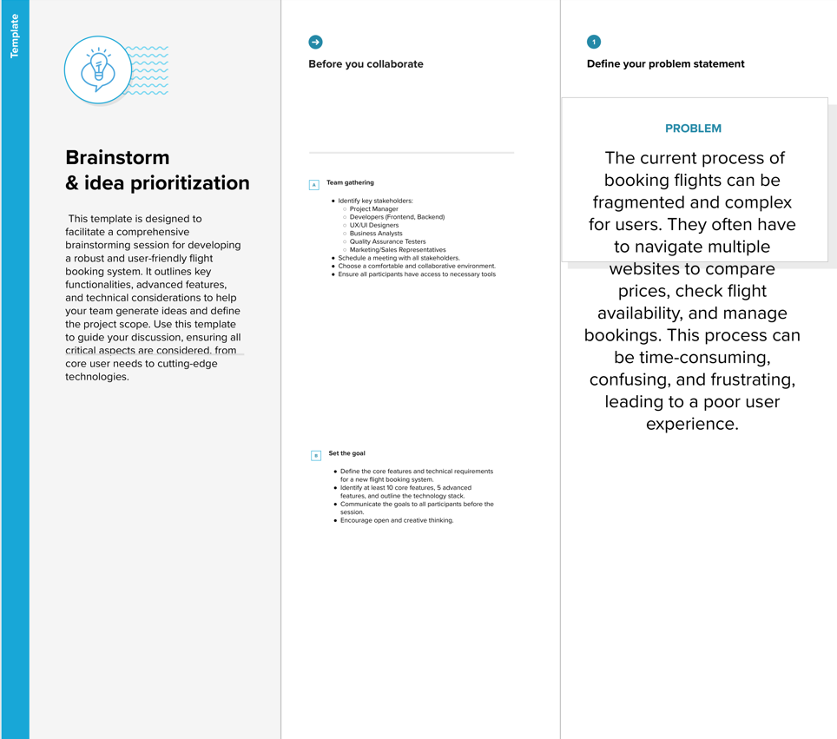

**Step-2: Brainstorm, Idea Listing and Grouping**

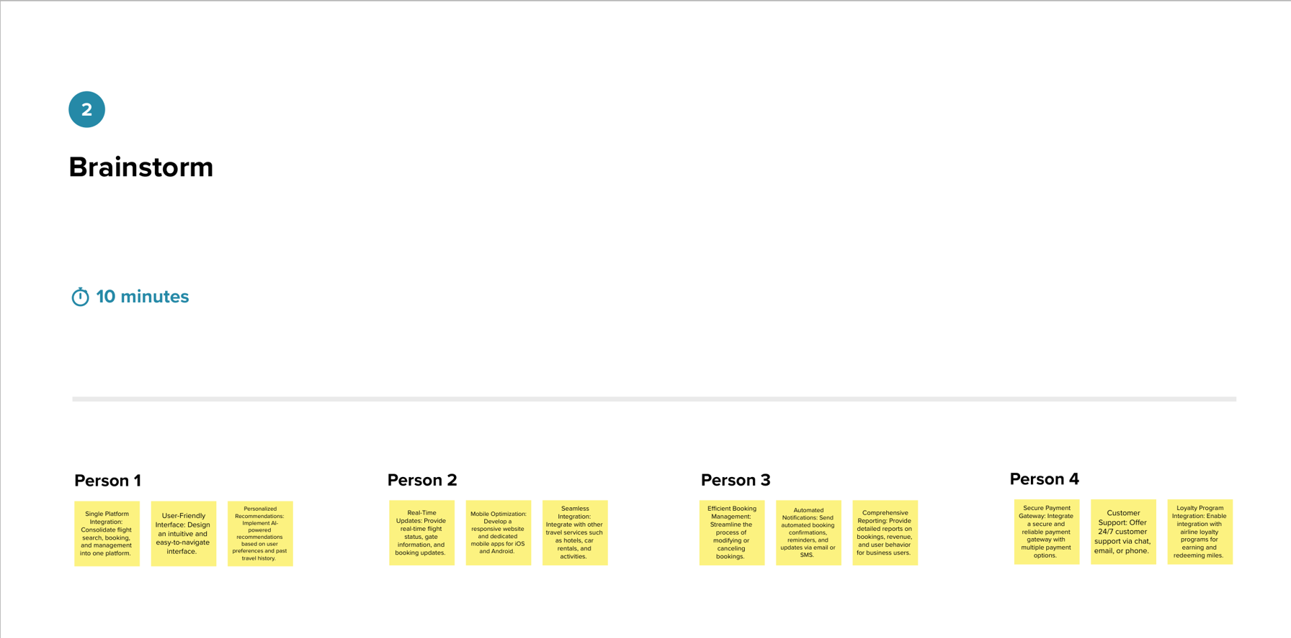

**Step-3: Idea Prioritization**

